Prof. Alexander Rohrbach, IMTEK
8. Tutorial to the lecture
Wave Optics SS 19
Solutions presented on 8.7.2019
Tutors: Rebecca Michiels, Tetiana Udod and Matthias Allkemper


Exercise 31 – Transmission grating (Exam level)
Sunlight falls onto a transmission grating with 5000 lines per cm.
- Do the diffraction orders m=+2 and m=+3 of the spectra overlap. Assume sunlight to have wavelengths between red (λ = 780nm) and violet (λ =390nm)?
- Design a blazed structure of a transmission grating made of plastic (n = 1.50) and a reflection grating (5000 lines per cm) such that red is amplified in order m=+1.

Exercise 32 – Separation of sodium doublet lines (Exam level)
What is the minimum number of grating lines to separate the sodium doublet lines (λ₁ = 589.0nm and λ₂ = 589.59nm) using the diffraction order m=+3.

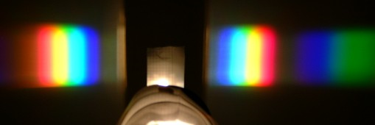
Continuous spectrum of a light bulb. The orders m=+1 and m=+2 are visible on the right, while on the left only m=-1 is viewable.

Exercise 33 - Binary phase grating
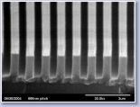
Consider a binary phase grating in air generating , where the grating period g is twice as broad as the slit width b. The maximum phase step is φ_{m}.
- Calculate the intensity spectrum distribution of the diffracted light. Demonstrate that the following equation is valid: |e^{iφ} - 1|² = 2⋅(1-cosφ).
- For which φ_{m} the diffraction peaks have maximum intensity and what happens for φ_{m} = 2π?
- The grating is made of PMMA (n = 1.42) and it is optimized for a wavelength of λ = 532nm. What is the height of the grating structure?
- What is the decrease in diffraction efficiency η (in %) if light with λ = 633nm is used?

Exercise 34 – Talbot effect (Exam level)
An electric field distribution E(x,z=0) that is periodic in lateral direction generates a periodic electric field distribution E(x,z) in propagation direction z as well (see figure below).
Such a periodic light pattern with a spacing of Δz = 100µm in z-direction is projected into a photosensitive polymer (refraction index n=1.40) using a mask with a lateral grating and light with a vacuum wavelength of λ₀ = 532nm.
- What is the lateral grating period of the mask?
- How can the shape of these recurring light patterns be changed without replacing the mask?

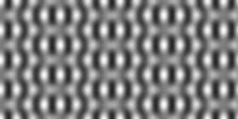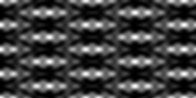
Re{E(x,y,z=0)} Re{E(x,y=0,z)} I(x,0,z)

Exercise 35 - AOM (if topic already covered)
A laser beam (λ = 633nm) is switched on and off with an AOM. The angle between the zeroth and first diffraction order has to be at least 5°, due to technical reasons. There are two crystals available: TeO₂ (n_{k} = 2.26, V_{ac} = 4200 m/s) und SiO₂ (n_{k} = 1.46, V_{ac} = 5960 m/s).
- Which of the two crystals would you chose to achieve low vibrational frequencies (the frequency of the acoustic wave)?
- What is the relative momentum transfer (in %) for the two crystals? Please, sketch the reciprocal grating.
- What is the change in laser frequency for the two crystals? (Exam level)
- Show how the AOM can achieve a diffraction angle of 5° for 532nm laser light using the TeO₂ crystal.
- What happens if the frequency of the acoustic wave is varied for a constant laser wavelength λ?

