Prof. Alexander Rohrbach, IMTEK
1. Tutorial to the lecture
Wave Optics SS 19
Solutions presented on ≈ 2.5.2019
Tutors: Rebecca Michiels and Felix Jünger

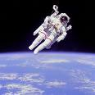
Exercise 1 - Radiation pressure as accelerator
- A poor astronaut (mass m = 100 kg) lost his spaceship. Luckily, he still has his flashlight (P_{opt} = 100 W) in his pocket and remembers some basic principles of photonics. How does he have to use his flashlight to get back to its spaceship (Simple drawing) and for how long should the batteries work inside his flashlight in order to accelerate himself to a velocity of v = 10 m/s.

- (Exam level) A solar sail driven spaceship with a reflector area of A = 1000 m² shall be accelerated to a velocity of v = 10 km/s within 12 months. What is the maximum possible mass of the spaceship to achieve this velocity?
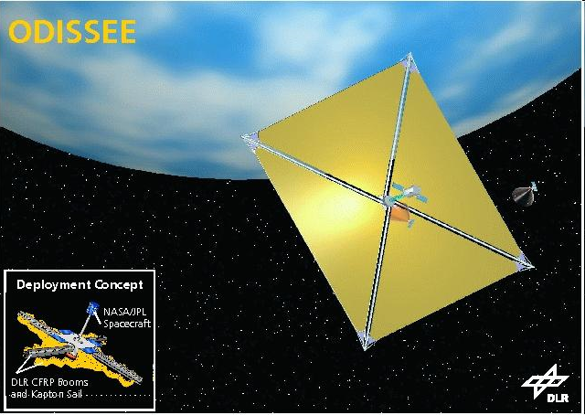
Small hint: the average optical power of the sun on the outer surface of the earth’s atmosphere can be approximated by the solar constant S₀ = 1367 W/m²

- So far, only momentum conservation was considered, but also energy conservation has to be fulfilled. The transfer of energy from the photon to the solar sail results in a frequency shift Δf of the light. In which situations is the frequency shifted to the red or to the blue? Find an expression for the change of the wavelength Δλ in dependence of the velocity v of the solar sail and the incident wavelength.
The following assumptions are useful:
- v is much smaller than the speed of light (v << c).
- The change of Δv caused by one photon is much smaller than v itself (∆v << v).

Exercise 2 - Photons per area (exam level)
In a nonabsorbing medium the optical power P exposed to an area A ~ r² remains constant, i.e. P = I⋅A = const. The corresponding square root is |E|⋅r = const.
- A light bulb emits radiation of P = 20 W (mainly IR light at λ = 3µm) isotropically. How large is the the spherical surface and the irradiance in a distance of r = 2µm? Compare this result with the irradiance of a 1 mW strong laser pointer, assuming a beam diameter of 1mm.
- How many photons per second hit a small detector area with A = 1 mm² ?
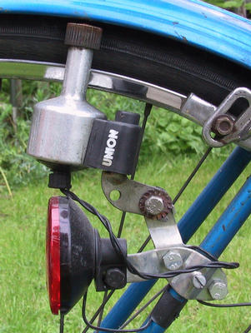
Exercise 3 - Induction in a conductor loop
The first Maxwell equation is also called the “law of induction”. Assuming a conductor loop, the left them describes the induced voltage, resulting from a line integration along the conductor loop. The term on the right side describes the temporal change of the magnetic flux . Since the flex is determined by the scalar product between the B- field and the surface normal n⋅dA, one can generate a voltage at the ends of the conductor loop by two different methods.
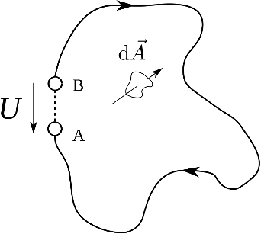
- Describe the change in flux mathematically for both methods. Assume a homogeneous magnetic field:
Hint: use the product rule
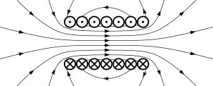
- A conductor coil with N = 200 turns rotates with angular velocity ω = 314 ⋅1/s in a homogeneous magnetic field of strength B = 50 mT. The quadratic loop as a side length of 10 cm. Which voltage U can be measured at the loop terminal?

Exercise 4 - Emission of a dipolar wave (only if presented in lecture)
Sketch 4 different emission stages of a dipole, which can reach a maximum dipole moment
p₀= q⋅x₀. Similar to the sketch of figure 4 in the script draw the dipole moments p = q⋅x for the displacement progress x = [0, x₀/2, x₀, x₀/2, 0 –x₀/2] together with the electric field lines establishing the dipole field. Draw all field lines with positive electric fields in one color, all field lines with a negative electric field in another color, so that the wave nature becomes visible.
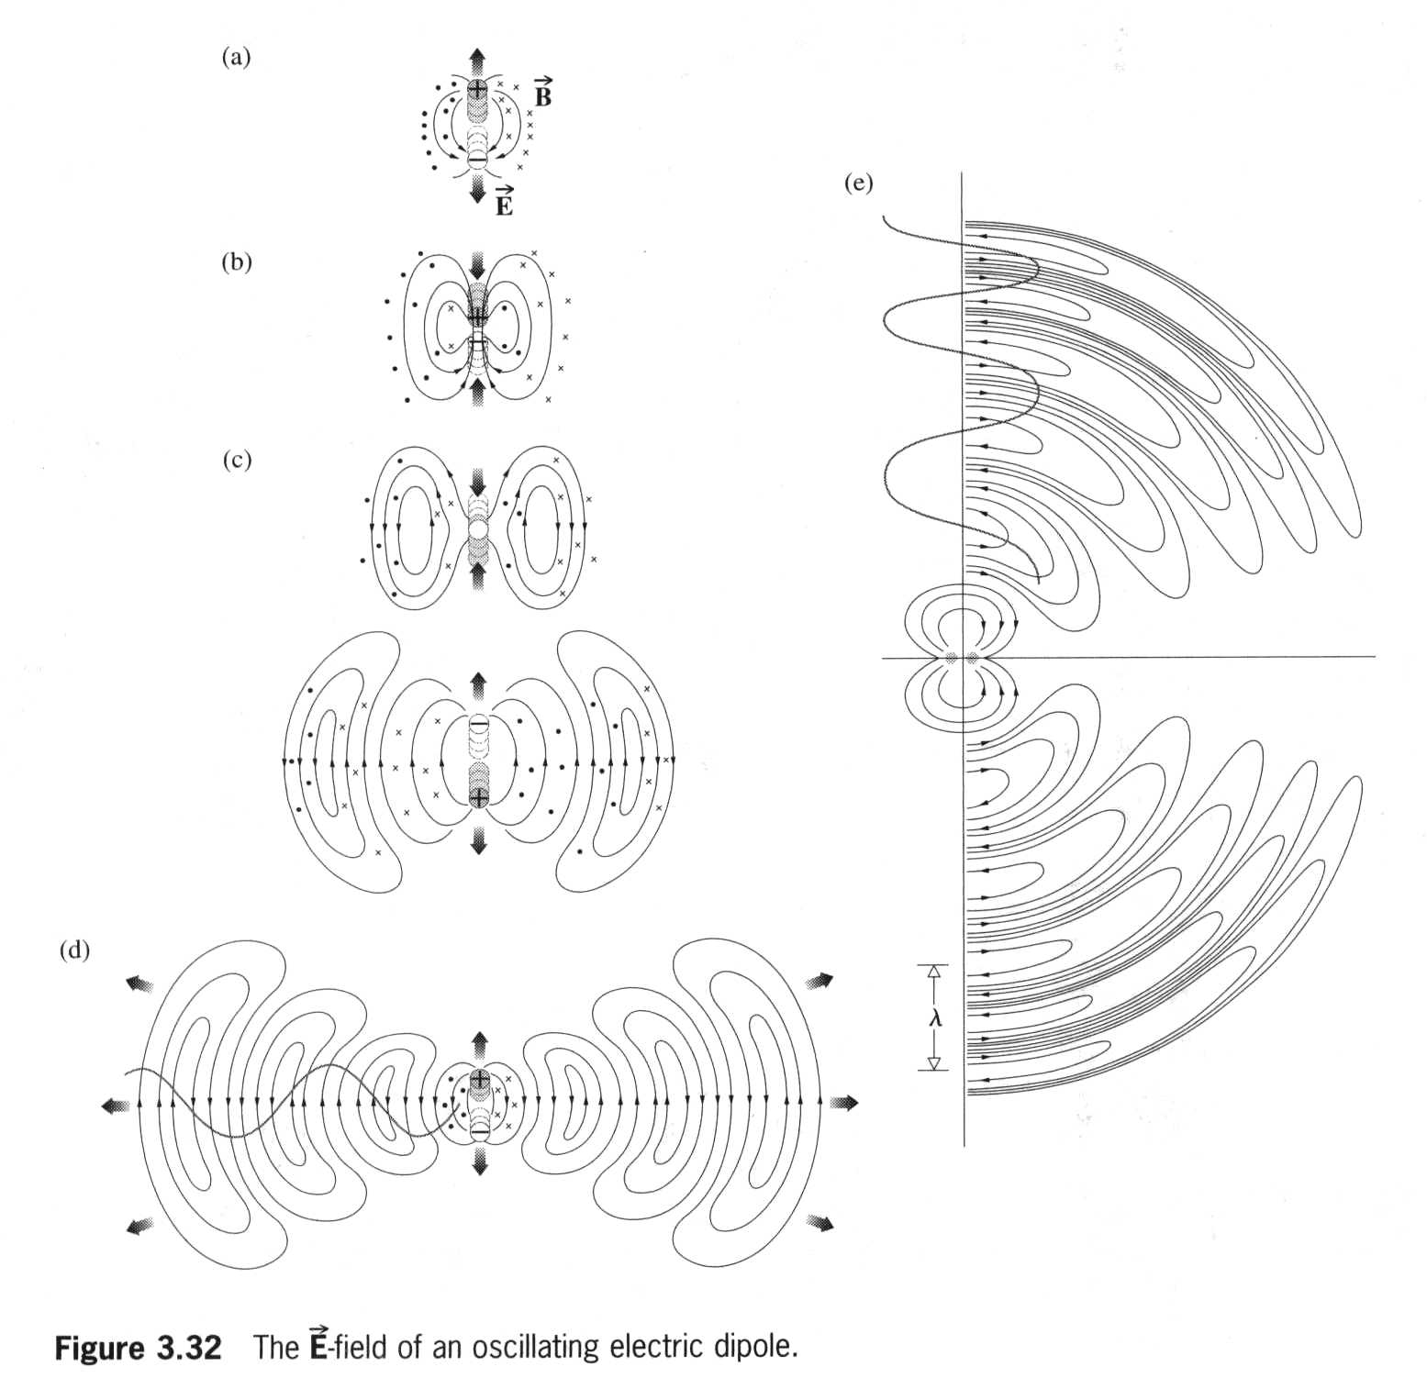
λ

